Systems Administrator

What does a systems administrator do?

Responsible for the whole computer system and networks/ general maintaining / making everything is working fine

Complete the table:

|  |
| --- |
| deploys new software / looks after network security / sets up user accounts / works on a help desk  designs databases / updates software across an organisation / writes software to sell to other companies |

|  |  |
| --- | --- |
| A systems administrator’s task | Not a systems administrator’s task |
|  |  |

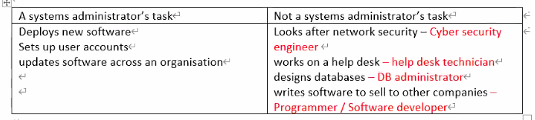

For each task in the right column, what is the correct job title?

Listening:

1. Is it a small company? How do you know? No – because there are many departments
2. What SIX topics does the first man ask Kevin about? Software upgrade / Backups / New staff members / Improving security / Checking logs / Any other problems

Listen again and check the correct column. If there was a problem, what was it?

|  |  |  |  |
| --- | --- | --- | --- |
|  | Worked fine | Problem found | Not mentioned |
| 1. Deploy new software upgrades |  |  |  |
| 1. Deploy new software applications |  |  |  |
| 1. Backup systems |  |  |  |
| 1. Disk drives |  |  |  |
| 1. Set permissions |  |  |  |
| 1. Check logs |  |  |  |
| 1. Reset passwords |  |  |  |

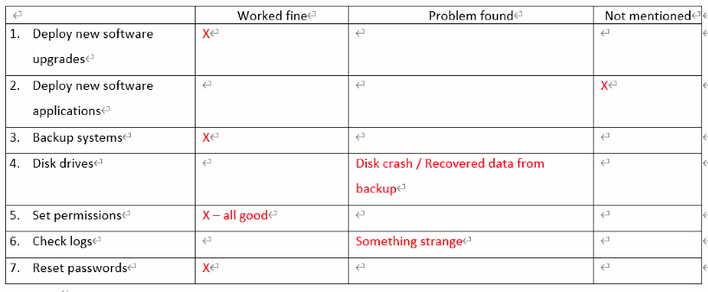 Find words from the table which match these definitions:

1. Change; set again: reset
2. Install on many computers at the same time: deploy
3. Settings on a computer, file or folder that say who can use it: permissions
4. Data that a program or computer produces while it runs, to show how well it is working: logs

~~Complete these phrases:~~

|  |
| --- |
| ~~crash out out of running again smoothly (x2)~~ |

|  |  |
| --- | --- |
| 1. ~~Run smoothly (no problems)~~ 2. ~~Disk crash~~ 3. ~~Be up and running again~~ | 1. ~~Lock (someone) out of (something)~~ 2. ~~Check (something) out (look at)~~ 3. ~~Go smoothly~~ |

**Language 1:**



After you install the OS, train the users // After A, B – First is A

Before you train usrers, install the OS, // Before A,B – First B

Install the OS before you train the users // A before B – First A

Train the users after you install the OS // A after B – First B

After you install the OS, you should train the users = After installing the OS, train the users

After you install the OS, the computer will work faster

Write sentences using *while*, *before* or *after*:

Install the software / do a full backup - *Before installing the software, do a full backup.*

Install an operating system / the computer may reboot several times – While you install an AS, the computer may reboot several times

Deploy major software upgrades / train the users – After deploying major software upgrades, train the users

Replace the hard drive / everything will go smoothly – After you replace the hard drive, everything will go smoothly

Forget a password / reset it – Reset the password after you forget it.

Listen and write which actions should happen first in each case:

|  |  |  |
| --- | --- | --- |
| 1. Email the report 2. Partitioning the hard drive | 3. Checking the schedule  4. getting access | 1. You should ask if it’s ok |

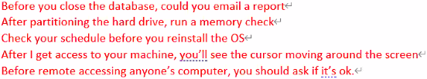

What precautions should you take in these circumstances?

1. Upgrade some software Before you upgrade, you should do a backup
2. Remote access someone’s desktop Before you remote access, you should ask them if it’s ok
3. Switch off a server with users’ computers networked to it sheck the users have saved everything



**Language 2:**

Grammar: Past Continuous

Forms:

|  |  |
| --- | --- |
| Positive | s+was/were + verb-ing  She was cooking |
| Negative | s+was/were + not verb-ing  She was not cooking |
| Question:  Question word  Yes/No answer | q-word(what,where,when) + was/were + S +verb-ing  What was she doing?  Was/were + S + verb-ing  Was she cooking? |

Usage:

To talk about an action in progress at a specific time in the past

* I was installing the software all day yesterday

To talk about an incomplete action that was interrupted by another action

Pattern: Past continuous pattern + when+ past tense verb

* I was installing the software yesterday when the computer crashed
* They were typing there report when i called

To talk about two actions that were happening at the same time

Pattern: Past continuous pattern + while + past continuous

* I was installing the software while they were rasting

Practice 1: Past Simple or Past Continuous

I was exercising (exercise) while my brother was studing (study)

She was downloading (download) a movie when the computer crashed (crash)

Why were you laughing (you / laugh) when I came(come) into the room?

What were you doing (you / do) while I was cleaning (clean) the house?

Were they reading (read) when you called (call)?

Practice 2:

|  |  |
| --- | --- |
| was looking the other way while I was having a bath when my battery died when he crashed I was eating dinner | my wife arrived home when it stopped working when the policeman stopped me I swallowed (삼키다) water when the dog attacked him |

Top of Form

* Tim was driving his car too quickly when he crashed
* my wife arrived home while I was cooking dinner.
* I was riding my bicycle on the footpath when the policeman stopped me
* The boy was delivering newspapers when the dog attacked him
* I was eating dinner when the phone rang.
* My sister was using the computer when it stopped working
* While I was swimming I swallowed (삼키다) water
* Unfortunately, the phone rang while I was having a bath
* I was speaking to my brother on the phone when my battery died
* The thief escaped while the policeman was looking the other way

What Were You Doing?

Ask your partner the following questions. Use the past progressive to answer:

Student A (ask to student B):

What were you doing this time yesterday?

I was eating lunch this time yesterday

-> what were you eating -> i was eating kimbab

What were you doing at 8 o’clock this morning?

What were you doing yesterday at noon?

What were you doing when your phone last rang?

What snack were you eating five years ago?

What were you doing before you went to bed yesterday?

Student B (ask to student A):

What were you doing this time two days ago?

What were you doing before this class?

What were you reading last year?

What were you watching on TV last year?

What were you doing when you last received a kakao message?

What were you watching on TV five years ago?